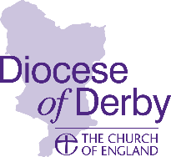
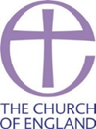
NOTICE OF ANNUAL
PAROCHIAL CHURCH MEETING

Parish of ASHBOURNE, ST OSWALD with MAPPLETON, ST MARY

A meeting will be held in St Oswald’s Church Hall

at 12h15 on Sunday 19th April 2026.

For election of parochial representatives of the laity to the Parochial Church Council.
For the election of parochial representatives of the laity to the Carsington Deanery Synod
For the appointment of the Independent Examiner.
For the consideration of:
(a) a report on changes to the Roll since the last Annual Parochial Church meeting.
(b) an Annual Report on the proceedings of the Parochial Church Council and the activities of the parish generally.
(c) the financial statements of the council for the year ending on the 31st December 2025
(d) the annual report on the fabric, goods and ornaments of the church.
(e) a report of the proceedings of the Deanery Synod and
(f) other matters of parochial or general Church interest.

(In this Notice, ‘parish’ means an ecclesiastical parish.)
The Annual Report and Financial Statements will be available to view on the website from 5th April 2026 www.ashbournechurch.org.uk . To request a hard copy please contact the Parish Office - Tel. 01335 343052 parishoffice@ashbournechurch.org.uk

Signed_____________________________________________________________________________
Minister of the parish (Or Vice Chair in Vacancy)

