

Director of Music – Application Pack



Information about St Oswald’s Church
With its soaring 212-foot spire, St Oswald’s Church is a landmark of Ashbourne and one of Derbyshire’s finest churches. Dedicated to 7th-century King St Oswald, it was consecrated in 1241, though Christian worship likely predates the Norman arrival in 1066. It is a beautiful, well-maintained Grade 1 listed building that attracts many visitors, featuring magnificent stained glass and historically significant memorials. Since Ashbourne is a tourism hub, we are striving to promote St Oswald’s as a key tourist attraction. It is a friendly and inclusive church that is a centre of the community and is used regularly as a venue for both religious and civic events.

St Oswald’s Church is part of The Ashbourne Group of Churches (St Oswald’s Ashbourne with St Mary Mapleton; St John’s Ashbourne; Holy Trinity, Clifton; St Peter’s, Snelston; and St Mary & St Barlok, Norbury). The Director of Music is based at St Oswald’s. We regularly visit the village churches (on the fifth Sunday of the month) for joint services with the choir.

We are associated with a number of excellent Church of England Primary schools (St Oswald’s, Clifton, and Norbury), where we often provide musical support for collective worship. We also have strong ties with Queen Elizabeth Grammar School.

The successful Director of Music will continue the tradition of musical excellence established over many years and aim to reach beyond it to engage those who are not yet part of our worshipping community. St Oswald’s Church community is grounded in Christian faith - creating a space of hospitality, exploration, imagination, and kindness. We rejoice in making space for all people to flourish and grow in heart, mind, and soul, and are committed to social justice and upholding the human dignity of everyone, regardless of age. We wish to enable people to live faithfully and think critically in a place dedicated to learning and discovery. We aspire to be a school for the soul, enriching the inner life through prayer, our building, music, the arts, and community.

For more information about St Oswald’s, check out our website at ashbournechurch.org or find us on Facebook and Instagram.

Our Worship
The tradition of services at St Oswald’s Church is liturgically central. Vestments are worn, and either Common Worship or BCP is followed. Hymns are currently chosen from ‘Common Praise’. There is both a sung Holy Communion and a sung Evensong each week (one fully choral service once a month). Worship is done well without being precious. There is a monthly Breakfast Church and Messy Church (the Director of Music is not currently involved in either service).

Music Ministry
There has been a robed choir here for about 200 years. The choral tradition continues to be a real strength of St Oswald’s, with a regular choir of about 18 (with 30 choristers on the books) and two well-qualified organists to assist as required. Music is vital to the mission of our church: to worship God and to make God known. Our current long-standing Director of Music (27 years in post) is retiring and will be missed. He is planning to remain a part of the St Oswald’s community on retirement. The choir currently rehearses on Friday evenings and sometimes before a service, especially for a Choral Evensong. The church has a strong connection to RSCM, and we look forward to building on that relationship in the future. Recitals and concerts are held regularly throughout the year in the church, with many taking place during the Ashbourne Festival in June.

The Instruments
Our organ was completely restored and improved in 2011 by Henry Groves and Sons, in whose care it remains. Go to https://ashbournechurch.org.uk/new-visitors/history/the-organ/ for full organ specification.

We also have a beautiful 2024 Feurich grand piano that is used regularly, especially during the recital season. We have a Broadwood upright piano in the chancel, primarily used for practice, and another piano in the church hall.

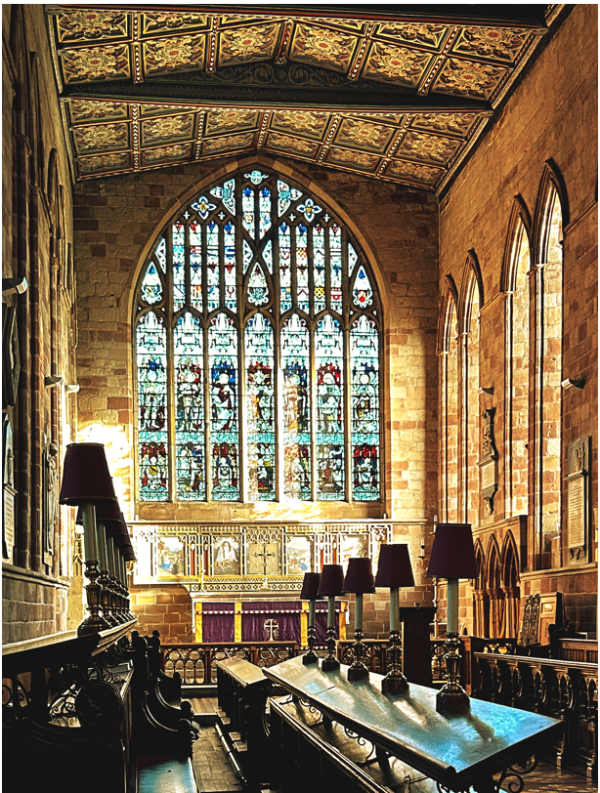

Our Simple Vision for St Oswald’s Music Ministry
(Created 2026 by the Music Ministry Working Group in preparation to advertise for this post)

Vision:
A worshipping community nourished and encouraged through music

Purpose:
St Oswald’s sees and values music as having a purpose to enrich worship, to inspire congregations, to support those who are active contributors to the ministry of music, and to develop and grow links to and with the local and wider community. To fit into St Oswald’s wider liturgical goals to provide an inclusive space for encounter, celebration, and lament, where open dialogue enables difficult issues to be explored safely.

Mission:
St Oswald’s will support and enable music to:
- Inspire the congregation through well-planned and appropriate music, delivered to a high standard, and with integrity and meaning
- Grow the church younger
- Sustain and deepen our spiritual heritage, including music, liturgy, and the arts
- Open the church’s horizons by expanding music selected for inclusion in worship, but respecting and building on the inherited traditions
- Look outward towards the local community
- Enhance a wider involvement of the local community
- Make the best of the historic building through enhanced, additional musical synergy (e.g. through a curated recital series and through encouraging use of the church as a concert venue for appropriate music)

Values:
- Compassionate
- Community-orientated
- Encouraging
- Inclusive
- Servant-hearted
- Spiritually engaged

Role Description
We are seeking a talented musician, ideally an organist with RCO diploma standard or equivalent, to become our Director of Music. Someone who is keen to help us develop our already strong music offering by growing our existing choir, developing a Children’s Choir and potentially starting a Community Choir. We would also like the scope for our Director of Music to potentially run concerts in our beautiful Church.

Our dream candidate would be someone willing to work collaboratively with our new priest-in-charge (who started in September 2025) to grow and develop our music offering, not just at church but also in the community. The congregation has a strong desire to maintain our tradition of a robed choir while we explore new hymnody and more diverse musics.

The role would suit a positive, energetic, and creative person with a sound musical background. It would also be desirable if they have experience in leading and encouraging children and young people to take an active part in our church music.
The position will involve playing the organ and, on occasions, the piano as well as leading/conducting the robed choir each Sunday. We have two services on a Sunday with music, the 10.30am Holy Communion and the 6.30pm Evensong. There are also the extra services at Advent, Christmas, and Easter. Additional fees will be paid for Weddings and Funerals. We had 42 funerals and three weddings in 2025, with nine weddings booked for 2026.

The post-holder will be expected to be a key face and voice of the church to the wider community. This position requires a strong degree of professionalism and the ability to work in an ever-changing environment, where multitasking, sound decision-making, self-motivation, and discretion are essential. Equally, the post-holder will need confidence and proven organisational, communication, and interpersonal skills. Please note this role requires a DBS check and safeguarding training.

Exciting Potential Mentor/Mentee Option
We are happy to appoint a successful candidate to the sole role of Director of Music.

Alternatively, our PCC and the Music Ministry Working Group were enthusiastic about sharing the role between two individuals – a mentor and a mentee – offering a potential ‘musical curacy’ for a mentee with limited experience who hopes to eventually become a Director of Music. This would provide opportunities for the mentee’s development while giving the mentor greater flexibility with their time. If you are interested in pursuing this, advertising for the mentee would take place after you have taken up your position. The £9,000-£10,000 per annum budget would need to be split between the two roles. Finances and time availability to be determined through consultation with the successful mentor applicant.
Job Specification
Job Title: | Director of Music
Reporting to: | The Incumbent. If in vacancy, Churchwardens.
Key Relationships: | The Incumbent, Churchwardens (and through them, to the PCC), other clergy, Sacristan, Parish Administrator, other organists, musicians, and choir members (and potentially mentee)
Key Responsibilities: | Responsibility for the music at St Oswald’s Church

Terms and Conditions:
The detailed terms and conditions will be contained in the postholder's Contract of Employment. 10 hours per week, paid monthly in arrears by direct transfer. Approx. £9,000-£10,000 per annum (before weddings and funerals) for the sole role or split between mentor-mentee roles. Leave should be agreed in advance (25 days per annum pro rata), bearing in mind the particular demands of preparation for major church festivals. Currently, the choir takes most of August off.

Probationary period: There is a standard six-month probationary period. One week’s notice of termination of employment will be required on either side during the first six weeks of the contract during the probationary period; thereafter, one month’s notice on either side will be required.

The Incumbent will, in consultation with the post-holder, regularly review the duties and responsibilities of the role, as well as discuss development, common concerns, and opportunities for training.

Duties/Responsibilities to include:
- Leading the music during worship and playing appropriate music of one’s own choice before and after services, extemporising as appropriate during services
- Rehearsing, developing, and growing the choir
- Working flexibly with the relevant people, under the Incumbent’s leadership, in planning the music for Sunday services and at other services, including major festivals
- Under the direction of the Incumbent and in collaboration with others responsible for music, to develop the musical expressions of worship in the church
- Prepare and organise the music and resources needed before any service or performance, with monthly copies available for the Church news, churchwardens, and in church, communicating with the choir and other instrumentalists in a timely manner to enable them to rehearse and prepare
- To explore developing a Children’s Choir
- To manage the recruitment, appointment, management, training and development of the child choristers, making good use of RSCM materials for Bronze, Silver, and Gold awards
- Organise occasional concerts or recitals
- Playing the organ and/or leading the choir for weddings and funerals (when able)
- Although predominantly at St Oswald’s, the successful candidate will provide support, assistance, and oversight in arranging organists/music at the other churches
- To oversee the music library, ensuring that music is catalogued, maintained and purchased
- Be proactive in ensuring proper maintenance of the instruments (i.e., arranging for tuning, maintenance, and addressing minor issues)
- To attend required meetings, including regular team meetings and meetings with wedding couples to discuss their musical requirements
- Ensure that PCC policies, including safeguarding and health & safety policies, are followed and properly implemented

The person ideally will:
- Be in sympathy with the Christian ethos of St Oswald’s Church and the Ashbourne Group of Churches
- Be able to demonstrate skills and experience that will deliver the above duties
- Be able to act with complete confidentiality and compassion towards others within our churches and the wider community which we serve
- Be able to communicate well with church leaders and members of the public from all walks of life, cultures, and backgrounds
- Be able to work with limited supervision and be pro-active (and a good team player)
- Have experience of liaising with volunteers
- Will be well-organised and efficient with a good attention to detail
- Be computer literate

For more details:
Please e-mail parishoffice@ashbournechurch.org.uk or vicar@ashbournechurch.org.uk or call 01335 343052. Please note that references and DBS, as part of our safer recruitment policy, will be requested at a later date.

If you have the necessary gifts, skills and experience, please email your application form and cover letter to parishoffice@ashbournechurch.org.uk and vicar@ashbournechurch.org.uk.
Closing date: 8 May 2026

APPLICATION FORM

Application for the post of: | Music Director of St Oswald’s Church, Ashbourne

This form should be used to apply for the role. It contains important information which will be used to assess your application for the role, as well as confirming your employment and personal details. Please note that a Curriculum Vitae is not an acceptable substitute. Therefore, please ensure it is accurately completed and that you have clearly demonstrated how you meet the role's requirements. Please submit by the closing date of 8 May 2026 to parishoffice@ashbournechurch.org.uk.

As an employer, we are committed to equal opportunities

SECTION 1 – PERSONAL DETAILS

Surname |  |  | Title |  | |
Forenames
Address
Telephone |  | E-Mail
Are you eligible to work in the UK? No |  | Yes (please circle as required)

Are you free to remain and take up employment in the UK with no current immigration restrictions?

Yes □ No □

SECTION 2 – PRESENT EMPLOYER
i) Job Title

ii) Employer (with address)

iii) Date of appointment

iv) Present Salary

v) Period of notice required

vi) Please give a brief description of your current role

vii) Reason for leaving

SECTION 3 – PREVIOUS EMPLOYMENT/POSTS HELD (starting with the most recent)

From |  | To |  | Employer | Post & Brief Description of duties

SECTION 4 – EDUCATION AND TRAINING (Secondary/Further/Higher Education)
Please give details, with dates

From |  | To |  | School/College | Qualifications Gained

Other relevant training courses attended
Date |  | Course

SECTION 5 – OTHER INTERESTS (leisure interests, hobbies etc.)

SECTION 6
Please use this section to briefly state your reasons for applying for this post. Looking at the Job Specification and Person Specification please also give examples of how you meet the criteria. Examples can be from your work, volunteering, community or other activities etc.

SECTION 7 - REFERENCES

Please give names and addresses of two persons to whom reference can be made (one of whom should be your present/last employer). References for shortlisted candidates may be taken up prior to the interview, unless you advise otherwise now in respect of your employer reference. May we take up a reference from your employer prior to the interview? YES/NO

Name
Position held
Address
Telephone
Email
 | How long have you known this person and in what context do they know you? | How long have you known this person and in what context do they know you?

SECTION 8 – REHABILITATION OF OFFENDERS ACT 1974

Do you have any convictions, cautions, reprimands of final warnings that are not “protected” as defined by the Rehabilitation of Offenders Act 1974 (Exceptions) Order 1975 (as amended in 2013) SI 2013 1198
Yes/No *if you answered yes, please provide details and dates (use additional sheets if necessary).
Failure to disclose such convictions could result in dismissal. Any information will be treated in the strictest of confidence.

SECTION 9 – DECLARATIONS

- I understand that any false or misleading information given in this application may result in my dismissal if I am appointed.
- To the best of my knowledge and belief, the information supplied by me in each section of this form is correct.
- I hereby consent to the processing of sensitive personal data, as defined by the Data Protection Act 1998, involved in the consideration of this application.

Signature…………………………………………………………………… Date……………..

Closing date for applications | Friday 8 May 2026 noon
Interviews will be held on | Saturday 30 May
Start date | Flexible – Hope September 2026

Please submit by the closing date of 8 May 2026 to parishoffice@ashbournechurch.org.uk.

